Configuring Development environment in Delphi 2007
- Start Delphi IDE, Make sure any old version of CPRS related Packages are removed. If not sure, Go to Menu for Default options for Delphi applications as shown below:
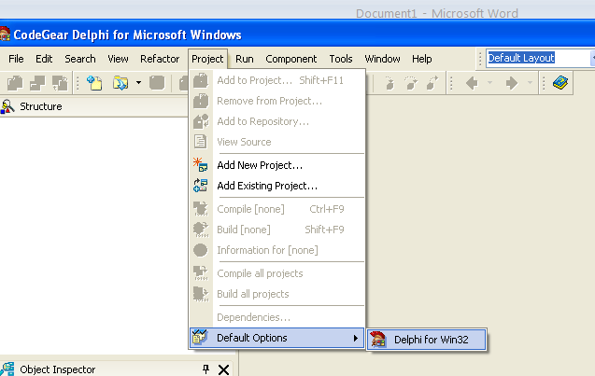
- In right side treeview, click on the item captioned “Packages” and then in the left side CheckBox Listview, scroll from top to bottom and see if any CPRS or VistA related component package is listed. If any such package is found then select that one and click on the button below captioned “Remove”. Make sure that no more CPRS / VistA related package is listed in that list and then close this dialog.

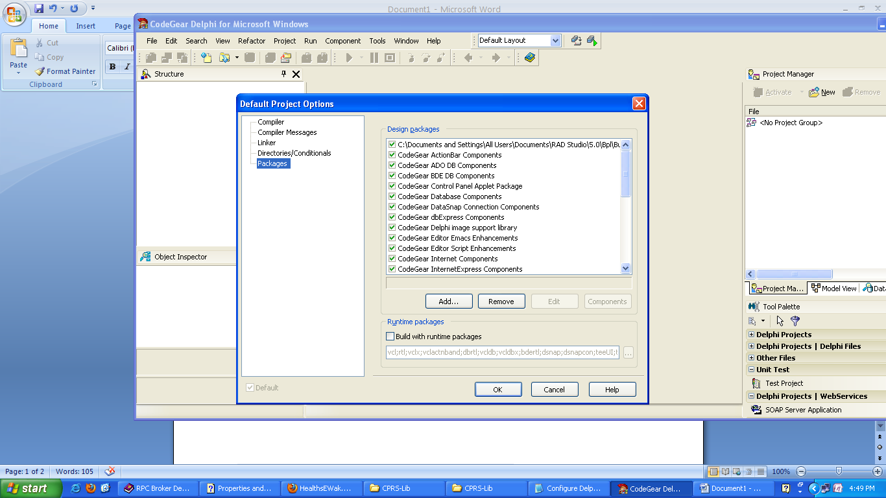
- Now we need to make sure that all the Library paths are correct by first removing any stale path (if any) and then adding the correct paths. To go to Library path settings, Click on Menu “Tools”→”Options” as below:
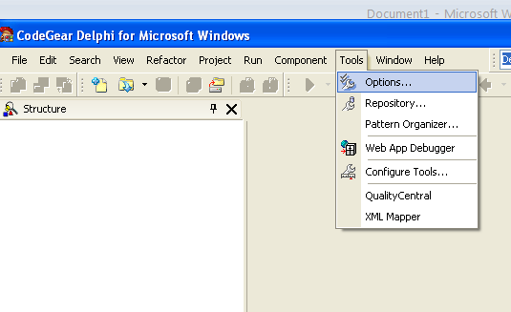
- In the next dialog screen, in right side tree view pane, make sure that all items are expanded then make sure that “Environment Option”→”Delphi Options”→”Library-Win32” tree item is selected as in following screen shot, and then click on first browse buttons with three dots (highlighted as little yellow in following screen shot) for “Library path:
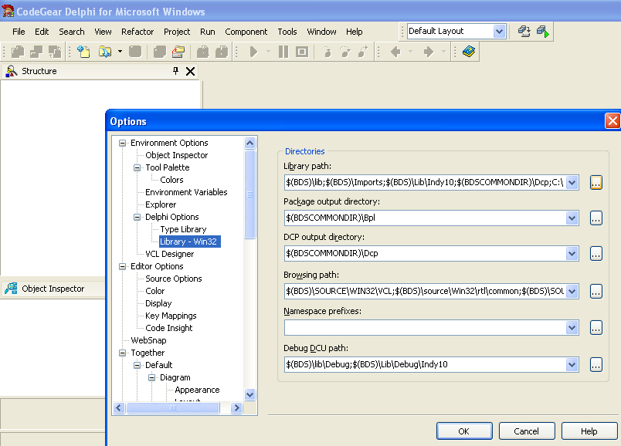
- Now the Library path dialog would open. Check all the paths listed and remove any stale path by first selecting it and then clicking on the button captioned “Delete”.
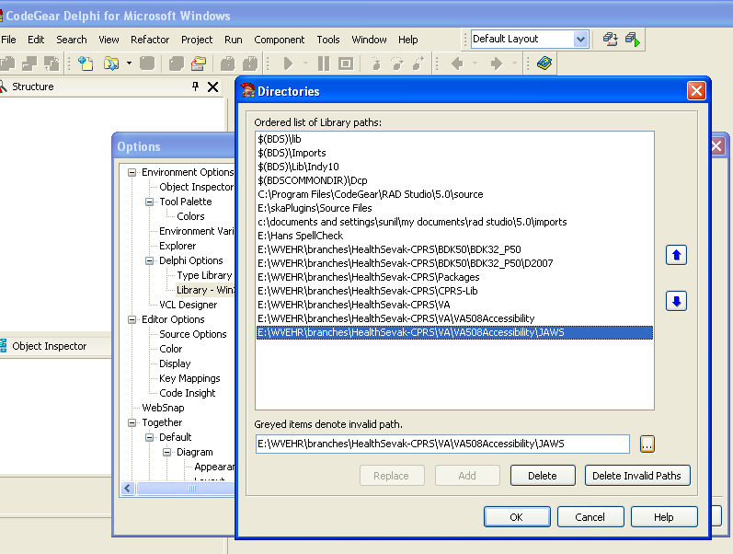

- Now add all the required paths one by one by first browsing to required folder by using the browse button captioned with three dots and highlighted in yellow in above screen shot (above button for “Delete Invalid Paths”), select required folder in “Select Folder” dialog which will open and then make sure to click on “Add” button. At least eight folder paths need to be added for CPRS development (last eight in above screen shot). Most of the paths in your system should be “………..\trunk\VA” or “….\trunk\CPRS-Lib” or “……trunk\CPRS-Lib\HanSpellCheck” and on same lines.
- Now that the stale packages and library paths are no longer there on your system and proper Library paths are configured we can install the required library packages as explained in next steps.
- Open the Package dialog again as done in first step
- In right side treeview, click on the item captioned “Packages” and then click on the button caption “Add”,
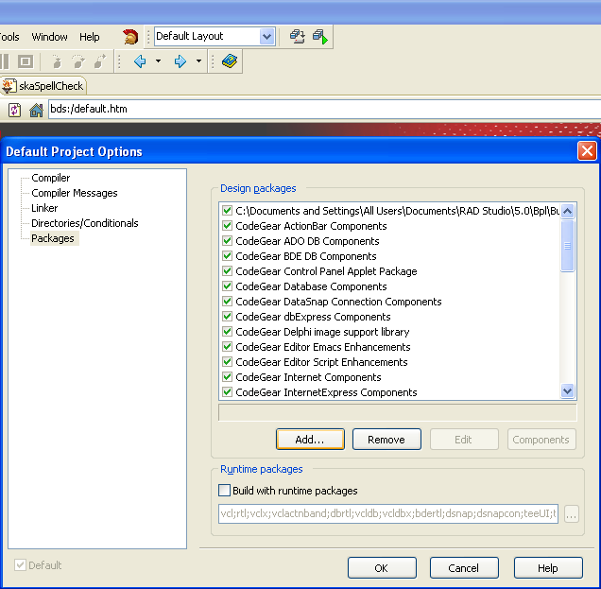

- Browse to the folder containing all the BPL files in your current working directory for CPRS source code (usually ……….\trunk\Packages), and one by one, select the following package files (in same chronological order as given here) one by one to get them added to Delphi package list:
  - VAShared2006.bpl (even in case of Delhi 2007 the suffix is same as 2006)
  - VA508Access2006.bpl
  - ORCtrlLib2006.bpl
  - ORDateLib2006.bpl
  - XWB_D2007.bpl (XWB_D2007.bpl only in case of Delphi 2006)
  - SharedRPCBroker_D2007.bpl (as per my understanding this could even be skipped)
  - VA10.bpl
  - MenuBarPackage
- In case any of the above addition of bpl fails then you may take the following recourse for that specific package; for example if “XWB_D2007/6” fails then search for the respective project source file with extension as “dproj” (XWB_R2007.dproj in this case). Usually it is in “….trunk\BDK50\BDK32_P50\Source” folder. Open this in your Delphi IDE as in following screenshot, right click on the project name in project explorer and click Install as below:
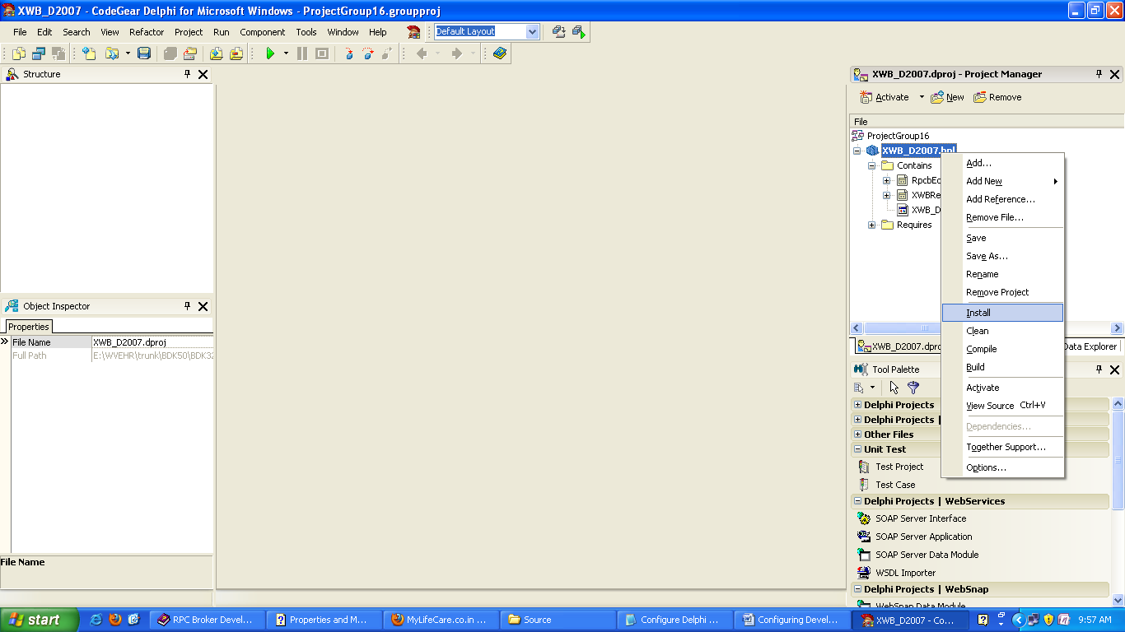
- Once all the above packages are installed, open CPRSChart.bdsproj and press “Shift+F8” to build.

